**COMfortel 1200 IP**

**Auto Provisioning User Manual**

CONTENT

1.Build HTTP/HTTPS Server 1

1.1 The Auto Provisioning Working Principle 1

1.2 Build HTTP/HTTPS Server 2

2. Place the configure file/software/kernel in Server 2

2.1 Auto Provision for Software 2

2.2 Auto Provision for Kernel 2

2.3 Auto Provision for Configure file 3

2.4 Auto Provision for Expansion 4

2.5 Auto Provision for Enterprise Phonebook 5

2.6 Auto Provision for Personal Phonebook 5

3.Configure parameters in Auto Provision Web page 5

3.1 Auto Provision using DHCP Option 66 5

3.2 Configure parameters in Auto Provision Web page 5

# 1. Build HTTP/HTTPS Server

## 1.1 The Auto Provisioning Working Principle

1. Build the HTTP/HTTPS server

2. Place the Auto Provisioning related file (configuration file/software/kernel) on the server.

3. Connect the phone by entering the server URL and download the file to update the phone’s configuration data or upgrade the software/kernel

4. There are three ways to start Auto Provisioning:

* Booting Checked: Auto Provision when the phone boots up

* Auto Provision Now (manually triggered)

* Time-scheduled Auto Provisioning

## 1.2 Build HTTP/HTTPS Server

The Auto Provisioning server doesn’t distinguish the type of the server; it only needs the server to support the HTTP/HTTPS protocol.

If you already built an HTTP/HTTPS server, you only need to place some related auto provision files on the server and configure the parameter settings on the auto provision web page.

If you have not set up an HTTP/HTTPS Server, we suggest downloading the server SW from the Internet.

**Http server**: hfs server

If you finished building your HTTP/HTTPS server, you can place an auto provision file on the server and configure the parameters on the auto provision web page.

# 2. Place the configure file/software/kernel in Server

When the software or kernel auto-provisioning is enabled, CFT 1200 IP will check the software and kernel version at first, so we need to make some pre-configuration on the provisioning server.

## 2.1 Auto Provision for Software

1. Create a notepad file named “**FD0001200.cfg**”.
2. Open the notepad file “FD0001200.cfg” and write the new software file name in it, the software file name format must be like this: **S2_COMfortel_1200_MD5_version3.4.2.3-7322**

Write down the new version you want to upgrade and save it on your provisioning server.

*\*Please note that if the version is the same (or older) as the one on your phone, auto-provision of your software will not be executed.*

1. After this, upload the new software file to the HTTP/HTTPS provisioning server and complete the pre-configuration steps.

## 2.2 Auto Provision for Kernel

1. Create a file named “**KD0001200.cfg**”, e.g. with Notepad.
2. Open the file “KD0001200.cfg” with a text editor (e.g. Notepad) and write the new kernel name in it, the kernel file name format must like this:

**K2_uImage_100N_version2.7.2**

Write down the new version you want to upgrade and save it on your provisioning server.

*\*Please note that if the version is the same as the one on your phone, auto-provision of your* kernel *would be not available.*

1. After this, upload the new kernel to the HTTP/HTTPS provisioning server and complete the pre-configuration steps.

## 2.3 Auto Provision for Configure file

* **Name of configuration file:**

The configuration file on the provisioning server is named as the MAC address of the CFT 1200 IP itself. CFT 1200 IP supports two different configuration files for auto-provision:

1. Normal Configuration file:

Normal Configuration file is the configuration file of the phone. You can download it from your phone (You can see the following chapter to see how to download a configuration file from the phone) and modify it by yourself.

* The Normal Configuration file can be separated into:
* Global parameters configuration file：for example Audio Codecs, Volume levels, Server URL, etc. Add these global parameters to a file as named **Public.xml**.

*Reference XML document*： 

* Private parameters configuration file: for example, specific account configurations by phone, the filename format must be MAC.xml, for example **001122334455.xml**.

*Reference XML document*：

1. How to create the Configuration file

* Download a configuration file from your phone:

You can download a configuration file from your phone by HTTP as follow:

1. Open the web page of your IP phone, click “Phone Maintenance”>“HTTP Upgrade”;
2. Then click “Download” of Configuration:

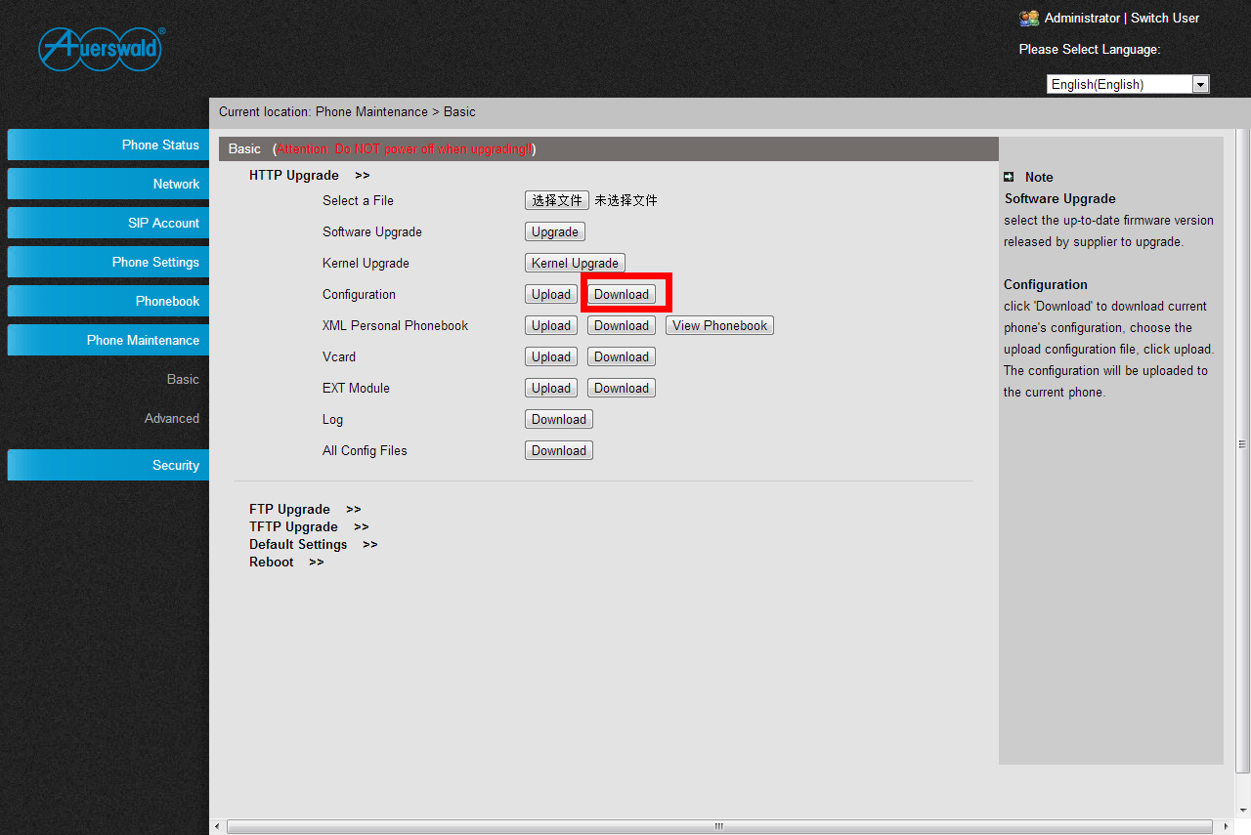

1. If you want to use this file to auto-provision, you just need to modify it by yourself and rename it to the MAC address of your Phone with an .xml suffix.

* Create the Configuration file manually

If you want to create the Configuration file manually, you must read this *reference document about the* Configuration file format details with explanations of the main parameters of the Configuration file:



## 2.4 Auto Provision for Expansion

The Extern.xml includes the settings of programmable buttons on the phone and all Expansion Modules (Expansion Modules do not apply to CFT 1200 IP). All phones can download the settings from the same file and they will have the same settings (for example, Speed-dial, BLF and so on).

*\*You can’t rename the file on the provisioning server. The file name is fixed to* ***Extern.xml****.*

*Reference XML document:*

## 2.5 Auto Provision for Enterprise Phonebook

COMfortel 1200 IP supports an Enterprise Phonebook and a Personal Phonebook. They use the same XML format; please refer to the reference documents.

* **Enterprise Phonebook:**

Enterprise Phonebook is used for all staff in your office. All phones will download a common phonebook for all employees. The file name must be ***Enterprise_Phonebook.xml*** on your provisioning server and you cannot rename it.

Reference XML document: 

## 2.6 Auto Provision for Personal Phonebook

* **Personal Phonebook:**

The Personal Phonebook is individual for each phone. The file on your provisioning server is named by the first account of your IP phone. If the IP phone’s first account is 1287, the Personal Phonebook of this phone is ***1287_Phonebook.xml***.

Reference XML document:

# 3. Configure parameters in Auto Provision Web page

## 3.1 Auto Provision using DHCP Option 66

You can use HTTP for auto-provision of the phone. If you don’t use option 66, you can jump to section 3.2.

## 3.2 Configure parameters in Auto Provision Web page

* **Login in to the phone’s web UI:**

1. Input the IP Phone’s IP Address in browser;
2. Enter user and password with “root” then open the web page;
3. Click “Phone Maintenance” and select “Auto Provision”;
4. select like as follows:

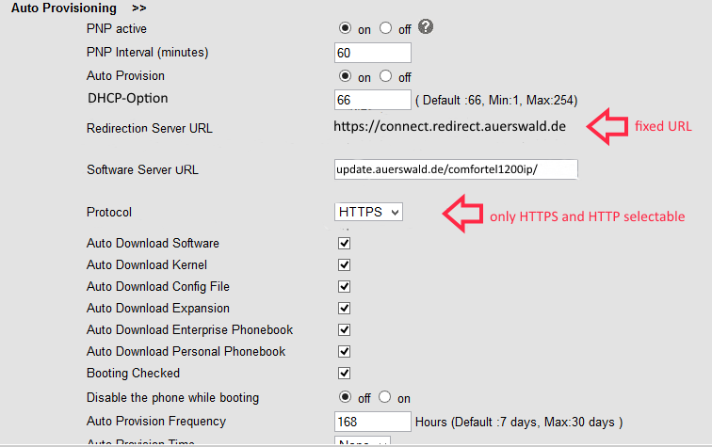

Supported protocols for Auto-Provisioning: HTTP/HTTPS

The format with provisioning server URL is:

**HTTPS:**

HTTPS://update.auerswald.de/comfortel1200IP is the default Software Server URL

Notice: You only need input the URL path, don’t need input the filename.

* **Auto Download Software:**

Download software from server and upgrade it automatically.

* **Auto Download Kernel:**

Download kernel from server and upgrade it automatically.

* **Auto Download Configuration File:**

Download configuration file from server and update it automatically.

* **Auto Download Enterprise Phonebook:**

Download Enterprise Phonebook from server and update it automatically.

* **Auto Download Personal Phonebook:**

Download Personal Phonebook from server and update it automatically.

* **Booting Checked:**

Check all items you had selected and upgrade/update them when the phone boot

* **Auto Provision Frequency:**

The auto provision Frequency which you want.

* **Auto Provision Time:**

The time you want to execute auto-provision.

* **Timing Auto Provision**

Examples of Auto Provision Frequency and Time:

1. When you set the Auto Provision Frequency and disable Auto Provision Time (set to None), the Auto Provision function will work after the Auto Provision Frequency;
2. When you set both Auto Provision Frequency and Auto Provision Time, for example:

You set the Auto Provision Frequency to 24 hours, and the Auto Provision Time to 2:00 at 8:00 today (1, Jan), it will pass 24 hours at first and work at the nearest 2:00, it means that the Auto Provision function will work at 2:00 on the day after tomorrow (3, Jan).

Therefore, if you want this function work at 23:00 tonight and it is 8:00 now, you need to set the Auto Provision Frequency to 0 hours and the Auto Provision Time to 23:00.

1. If you finished the configuration of Auto Provision Frequency and Auto Provision Time, you can click the button of “**Reset Timing**” and timing is finished.
2. **Auto Provision Next Time:** shows next start time for Auto Provisioning

* **AES Encryption:**

AES encryption is used for all the setting files of your phone (include configuration file, Expansion file, Enterprise/Personal Phonebook etc. You just need to enable the AES Encryption function and input the AES Key matching the one on your server on.

Reference AES Encryption documents: 